|  |
| --- |
| NAME: Ayush Vinod Upadhyay  ROLL NO: I025  SAP ID: 60003220131  BRANCH: Information Technology |

**Experiment No:9**

**To Examine the consistency of database using concurrency control technique (Locks)**

**------------------------------------------------EXERCISE--------------------------------------------**

1. When user 1 locks in read mode, user 2 can read without any conflict but cannot write as read – write is a conflict.

User 2 can read safely.

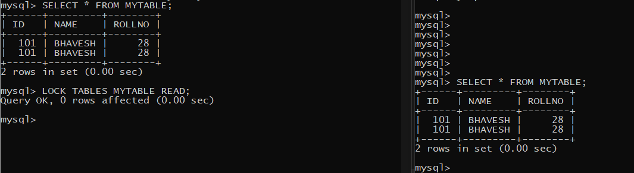

1. **Read – write conflict**

When user 1 is locked in read mode, user 2 cannot perform write operations.

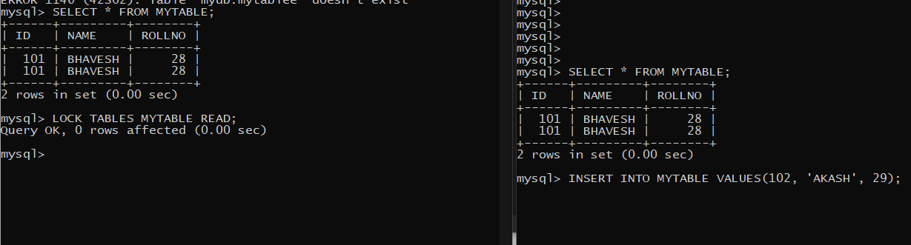

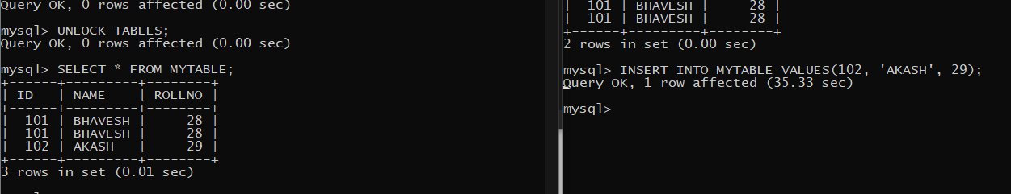

User 2 waits until the lock is removed by user 1.

Then user 2 successfully performs write operation.

Similarly, if user 1 is locked in write mode, user 2 cannot perform read operations.

User 1 in write mode.

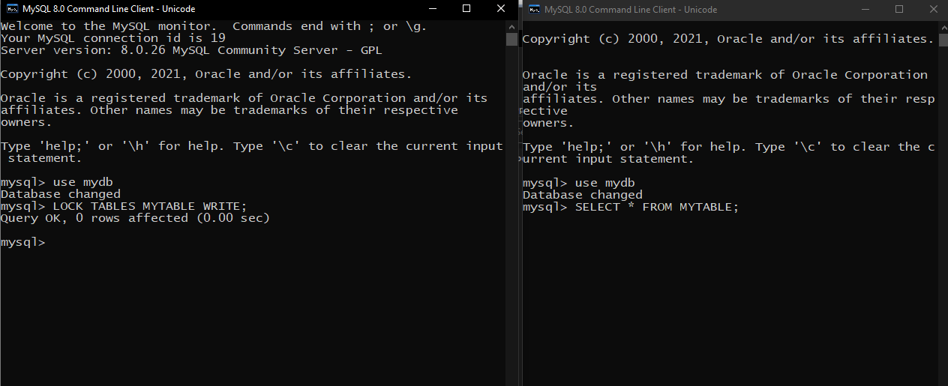

1. **Write – Write conflict**

Both users cannot write on the same resource at the same time as it is a conflict.

